

BCS3343 – SOFTWARE TESTING AND MAINTENANCE

**JUNIT Project**

(Online Ticketing)

Lecture’s Name

MDM ROZLINA BINTI MOHAMED

Member’s Name

NORUL HUSNA BINTI OTHMAN CB13008

NUR SYUHAIDAH BINTI ISMAIL CB13006

**1) System Overview**

The OnlineTicketing.java program supports functional testing of the programs. OnlineTicketing.java runs a complete set (file) of test cases, and produces a file of test case execution results. The Functional Test Case Executor has three programs that we can test here. The programs are CustomerIT.java, and DestinationTicketIT.java. This system will be test all the case whereby we want to find the solution for the case either all tests are ‘pass’ or ‘fail’. But some other situation, the system might be failed due to it failures to get the solution. So, not all of our inputs are wrong and maybe some of it is because of the system failure

**2) System Test Suite**

**A) Assuming the Total Price Ticket from different destination take the following ranges (with minimum**

Perlis >= 60.20

Kedah >= 58.60

Pulau Pinang >= 55.00

Perak > = 50.00

EP: A) = {-90.00, -1.00, 0, 11.00}

B) = {-1.00, 0, 65.00, 99.00}

C) = {25.00, 100.00, 27.00, 0}

D) = {0, 49.00, 88.00, -12.00}

E) = {-100.00, 10.00, 58.00,0}

|  |  |  |  |  |  |  |  |  |  |
| --- | --- | --- | --- | --- | --- | --- | --- | --- | --- |
| **Conditions** | **Test ID** | **A** | **B** | **C** | **D** | **E** | **Expected Results** | **Actual Results** | **NoTicket** |
| Perlis >= 60.20    Kedah >= 58.60    Pulau Pinang >= 55.00    Perak >= 50.00 | 1 | -90.00 | -1.00 | 25.00 | 0 | -100.00 | No result | No result | - |
| 2 | -1.00 | 0 | 100.00 | 49.00 | 10.00 | 100.00 | Pass | 1 |
| 3 | 0 | 65.00 | 27.00 | 88.00 | 58.00 | 27.00 | Fail | 0 |
| 4 | 11.00 | 99.00 | 0 | -12.00 | 0 | -12.00 | Fail | 0 |

**3) File TestOnline Package Coding**

***CustomerIT.java***

/**

* Test of getName method, of class Customer.

*/

public void testGetName() {

System.out.println("getName");

Customer instance = new Customer("aiman", "Damansara", "035617967","student", "kedah",3);

String expResult = "aiman";

String result = instance.getName();

try{

assertEquals(expResult, result);

System.out.println( "Name "+result+": validate");

}

catch(Throwable t)

{

System.out.println( "Name "+result+": Not validate");

}

Customer instance1 = new Customer("aiman", "Damansara", "035617967","student", "kedah",3);

String expResult1 = "feza";

String result1 = instance1.getName();

try{

assertEquals(expResult1, result1);

System.out.println( "Name "+result1+": validate");

}

catch(Throwable t)

{

System.out.println( "Name "+result1+": Not validate");

}

}

// TODO review the generated test code and remove the default call to fail.

//fail("The test case is a prototype.");

/**

* Test of getAddress method, of class Customer.

*/

public void testGetAddress() {

System.out.println("getAddress");

Customer instance = new Customer("aiman", "Damansara", "035617967","student", "kedah",3);

String expResult = "Damansara";

String result = instance.getAddress();

try{

assertEquals(expResult, result);

System.out.println( "Alamat "+result+": validate");

}

catch(Throwable t)

{

System.out.println( "Alamat "+result+" : Not validate");

}

Customer instance1 = new Customer("aiman", "Damansara", "035617967","student", "kedah",3);

String expResult1 = "Kepong";

String result1 = instance1.getAddress();

try{

assertEquals(expResult1, result1);

System.out.println( "Alamat "+result1+": validate");

}

catch(Throwable t)

{

System.out.println( "Alamat "+result1+" : Not validate");

}

}

// TODO review the generated test code and remove the default call to fail.

//fail("The test case is a prototype.");

/**

* Test of getTelephone method, of class Customer.

*/

public void testGetTelephone() {

System.out.println("getTelephone");

Customer instance = new Customer("aiman", "Damansara", "035617967","student", "kedah",3);

String expResult = "035617967";

String result = instance.getTelephone();

try{

assertEquals(expResult, result);

System.out.println( "Contact Number "+result+": validate");

}

catch(Throwable t)

{

System.out.println( "Contact Number "+result+": Not validate");

}

Customer instance1 = new Customer("aiman", "Damansara", "035617967","student", "kedah",3);

String expResult1 = "111111111";

String result1 = instance1.getTelephone();

try{

assertEquals(expResult1, result1);

System.out.println( "Contact Number "+result1+": validate");

}

catch(Throwable t)

{

System.out.println( "Contact Number "+result1+": Not validate");

// TODO review the generated test code and remove the default call to fail.

//fail("The test case is a prototype.");

}

}

/**

* Test of getDestination method, of class Customer.

*/

public void testGetDestination() {

System.out.println("getDestination");

Customer instance = new Customer("aiman", "Damansara", "035617967","student", "Kedah",3);

String expResult = "Kedah";

String result = instance.getDestination();

try{

assertEquals(expResult, result);

System.out.println( "Lokasi "+result+": validate");

}

catch(Throwable t)

{

System.out.println( "Lokasi "+result+": Not validate");

}

Customer instance1 = new Customer("aiman", "Damansara", "035617967","student", "Kedah",3);

String expResult1 = "Selangor";

String result1 = instance1.getDestination();

try{

assertEquals(expResult1, result1);

System.out.println( "Lokasi "+result1+": validate");

}

catch(Throwable t)

{

System.out.println( "Lokasi "+result1+": Not validate");

// TODO review the generated test code and remove the default call to fail.

//fail("The test case is a prototype.");

}

}

/**

* Test of getNoTicket method, of class Customer.

*/

public void testGetNoTicket() {

System.out.println("getNoTicket");

Customer instance = new Customer("aiman", "Damansara", "035617967","student", "kedah",3);

int expResult = 3;

int result = instance.getNoTicket();

try{

assertEquals(expResult, result);

System.out.println( "Jumlah Tiket "+result+": validate");

}

catch(Throwable t)

{

System.out.println( "Jumlah Tiket "+result+": Not validate");

}

Customer instance1 = new Customer("aiman", "Damansara", "035617967","student", "kedah",3);

int expResult1 = 1;

int result1 = instance1.getNoTicket();

try{

assertEquals(expResult1, result1);

System.out.println( "Jumlah Tiket "+result1+": validate");

}

catch(Throwable t)

{

System.out.println( "Jumlah Tiket "+result1+": Not validate");

// TODO review the generated test code and remove the default call to fail.

//fail("The test case is a prototype.");

}

}

/**

* Test of getCalculated method, of class Customer.

*/

public void testGetCalculated() {

System.out.println("getCalculated");

Destinationticket instance = new Destinationticket(3,"Kedah");

double expResult = 175.80;

double result = instance.getCalculated();

try{

assertEquals(expResult, result, 0.0);

System.out.println( "Total Price "+result+": validate");

}

catch(Throwable t)

{

System.out.println( "Total Price "+result+": Not validate");

}

Destinationticket instance1 = new Destinationticket(3,"Kedah");

double expResult1 = 58.60;

double result1 = instance1.getCalculated();

try{

assertEquals(expResult1, result1, 0.0);

System.out.println( "Total Price "+result1+": validate");

}

catch(Throwable t)

{

System.out.println( "Total Price "+result1+": Not validate" );

}

// TODO review the generated test code and remove the default call to fail.

//fail("The test case is a prototype.");

}

**Output Test Result**

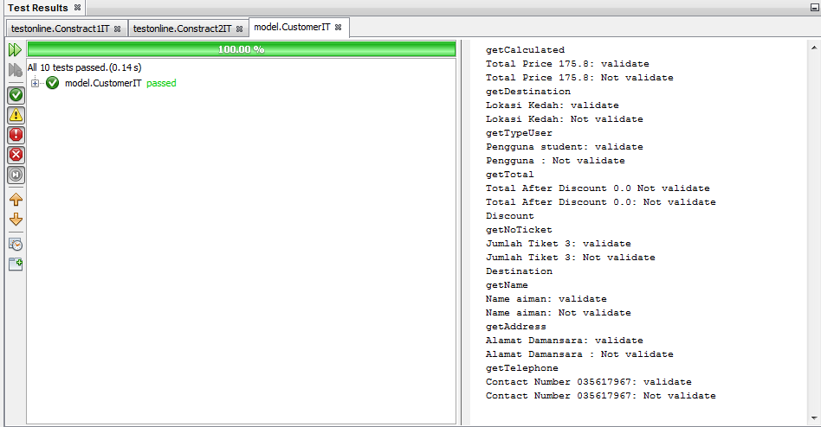

**Figure 3.1** Test Result CustomerIT

***DestinationTicketIT.java***

/**

* Test of getDestination method, of class Destinationticket.

*/

public void testGetDestination() {

System.out.println("getDestination");

Destinationticket instance = new Destinationticket(1,"Perlis");

String expResult = "Perlis";

String result = instance.getDestination();

try{

assertEquals(expResult, result);

System.out.println( "Lokasi "+result+": validate");

}

catch(Throwable t)

{

System.out.println( "Lokasi "+result+": Not validate");

}

Destinationticket instance1 = new Destinationticket(1,"Perlis");

String expResult1 = "Kedah";

String result1 = instance1.getDestination();

try{

assertEquals(expResult1, result1);

System.out.println( "Lokasi "+result1+": validate");

}

catch(Throwable t)

{

System.out.println( "Lokasi "+result1+": Not validate");

}

// TODO review the generated test code and remove the default call to fail.

//fail("The test case is a prototype.");

}

/**

* Test of getNoTicket method, of class Destinationticket.

*/

public void testGetNoTicket() {

System.out.println("getNoTicket");

Destinationticket instance = new Destinationticket (3,"Perlis");

int expResult = 3;

int result = instance.getNoTicket();

try{

assertEquals(expResult, result, 0.0);

System.out.println( "Jumlah Tiket "+result+": validate");

}

catch(Throwable t)

{

System.out.println( "Jumlah Tiket "+result+": Not validate");

}

Destinationticket instance1 = new Destinationticket (3,"Perlis");

int expResult1 = 1;

int result1 = instance1.getNoTicket();

try{

assertEquals(expResult1, result1, 0.0);

System.out.println( "Jumlah Tiket "+result+": validate");

}

catch(Throwable t)

{

System.out.println( "Jumlah Tiket "+result+": Not validate");

}

// TODO review the generated test code and remove the default call to fail.

//fail("The test case is a prototype.");

}

/**

* Test of getCalculated method, of class Destinationticket.

*/

public void testGetCalculated() {

System.out.println("getCalculated");

Destinationticket instance = new Destinationticket (1,"Kedah");

double expResult = 58.60;

double result = instance.getCalculated();

try{

assertEquals(expResult, result, 0.0);

System.out.println( "Total Price "+result+": validate");

}

catch(Throwable t)

{

System.out.println( "Total Price "+result+": Not validate");

}

Destinationticket instance1 = new Destinationticket (1,"Kedah");

double expResult1 = 60.00;

double result1 = instance1.getCalculated();

try{

assertEquals(expResult1, result1, 0.0);

System.out.println( "Total Price "+result1+": validate");

}

catch(Throwable t)

{

System.out.println( "Total Price "+result1+": Not validate" );

}

// TODO review the generated test code and remove the default call to fail.

//fail("The test case is a prototype.");

}

**Output Test Result**

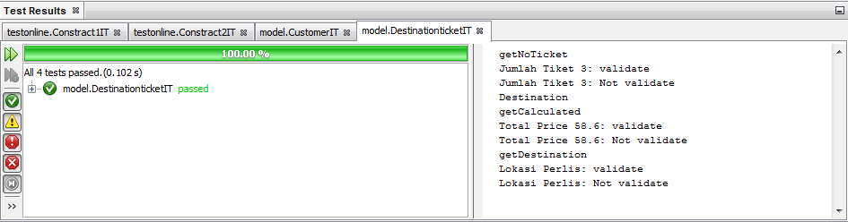

**Figure 3.2** Test Result DestinationTicketIT